Architecture Design for Team Application Project
INFO 465- Saran Diawara, Tiffany Nguyen, Madilynn Craig, Jeremy Siles

Cloud Service Provider

The cloud service provider used to host the application will be AWS. It offers easy scalability with the ability to adjust resources automatically based on changes in traffic on the application. This is cost efficient, ensuring that we will only pay for what we need. AWS also offers great security and a number of services that will be helpful for our application. We are interested in utilizing a number of AWS services such as EC2 for backend servers, RDS for mySQL, IAM for security, and S3 for storage.

Application Design
The application will be built using the Javascript programming language. Node will be used for the run-time environment as well as RESTful for the application’s API. The application’s framework will be Angular along with Express for its middleware. Lastly the port configurations will consist of HTTP Port 80, HTTPS Port 443, potentially Port 3000 for Node.js and Port 3306 for mySQL.

Database Schema and Design
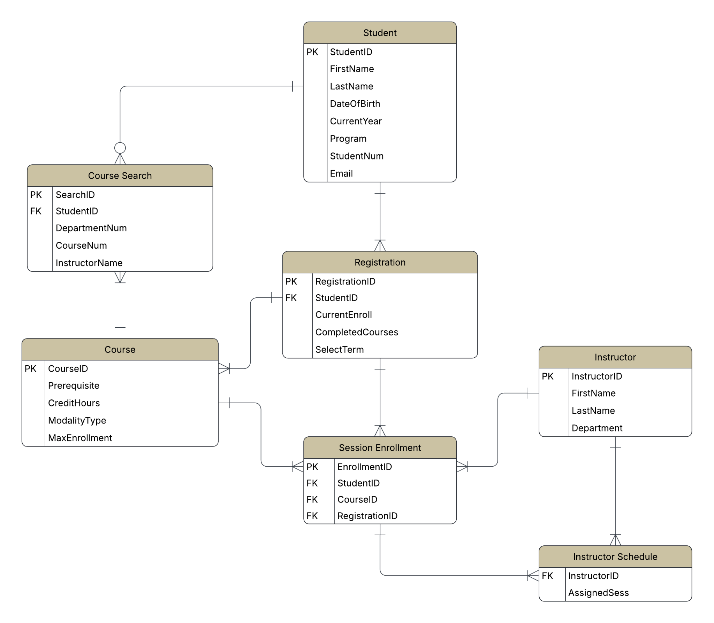

The database management system used will be MySQL.
Explanation of the Entity Relationship Diagram (ERD) schema:
- Student → Registration → Session Enrollment
- Student → Course Search
- Course → Course Search
- Registration → Course
- Course → Session Enrollment
- Instructor → Instructor Schedule
- Instructor → Session Enrollment
- Session Enrollment → Instructor Schedule

Network Architecture & Security
The network architecture is built around a single VPC using two availability zones to ensure redundancy.
- Public subnets - contain shared resources that need internet access, including the gateway, load balancer nodes, and NAT gateways.
- Private subnets - Has EC2 instances and have not direct inbound internet access, must come from load balancer.

The configuration of security groups:

Load Balancer (ALB)
- ingress - Allow HTTP(80) and HTTPS (443) from 0.0.0.0/0 (internet)
- Egress - ALlow all traffic to 0.0.0.0/0
Database
- Ingress - Allow My SQL from the web instance only
- Egress - Allow all traffic to 0.0.0.0/0
Application Instance
- Ingress - Allow custom support from ALB
- Egress - Allow all traffic to 0.0.0.0/0

Port Configuration
User-Facing Port
- Port 443 (HTTPS) - Primary port for all user traffic
- Port 80 (HTTP) - Configured to the ALB
Application Internal Port
- Custom Port - The ALB is configured via its target group to forward traffic on EC2 instances.

Data Visualization Tool
Our team has selected Power BI as our tool for data visualization.

Justification
- Functionality - Power BI dashboard is ideal for quick reporting.
- AI and Data Integration - Power BI “Quick Insights” feature, which uses machine learning find patterns.
- Team Familiarity - Familiarity with the Microsoft ecosystem. Learning curve on Power BI compared to tableau is significantly lower.
- Cost and Scalability - A cost effective choice for a growing team where plans range from $10-$20 per user per month. Provides enterprise-grade features at a fraction of the cost. Scales within the cloud as data volume grows.

Testing & Quality Assurance
For testing and quality assurance, our team will follow a process throughout each sprint to make sure our code works correctly and reliably. Unit Testing will check individual components, like database queries, API endpoints, or UI elements, to make sure each part does what it’s supposed to. Integration Testing will test how different parts of the system work together, such as the frontend communicating with the backend and the database. End-to-End Testing will simulate real user actions to make sure the full application behaves as expected, from logging in to navigating screens and processing data. This approach will help ensure our system is reliable, secure, and ready for the next steps in development.

Authentication & Roles
- System Access
  - For this project, the system is assumed to be open-access, meaning anyone can access the application without a real login or authentication system. Based on the assignment requirements, implementing authentication methods such as LDAP, OAuth, or other secure login services is outside the scope of this project. If this was a real-world program, you would need to log in with a student email. While some screens may include login fields to make the interface feel realistic, they are only for demonstration purposes and do not actually verify user credentials.

Roles

Student

Students are the main users of the system. They can:
- Search for courses
- View their enrolled sessions
- Register for available course sessions
- Avoid duplicate registrations and follow enrollment limits

Instructor

Instructors can:

View their assigned teaching schedules

Access information about the sessions they are teaching

View lists of students enrolled in their courses
Since authentication is not implemented, role permissions are only represented conceptually in the system design. In a real-world version of this application, access control would be handled through backend authorization and role-based permissions. For this project, roles are included mainly to guide how features and screens are organized within the application.

Team Contribution Summary

Name | Tasks Completed
Saran Diawara | Testing & Quality Assurance, Document Added to Github + Screenshot
Tiffany Nguyen | Authentication & Roles
Jeremy Siles | Network Architecture & Security, Data Visualization Tool
Madilynn Craig | Cloud Service Provider, Application Design, and Database Schema & Design sections

Collaborative/GitHub Screenshot

